***DO NOT WRITE ANYTHING ON QUESTION PAPER EXCEPT YOUR NAME, DEPARTMENT AND ENROLMENT No.***

Name of Student ---------------------------------------------------------- Enrolment No. ------------------

Department / School -----------------------------

**BENNETT UNIVERSITY, GREATER NOIDA**

**Mid Term Examination, Even Semester 2020-21**

COURSE CODE: MSOM188L MAX. DURATION:  **2 Hrs** COURSE NAME: Supply Chain Simulations and Heuristics MAX. MARKS: **25**

**Note : 1.** The question paper contains two sections -A and B. Section A is compulsory. Attempt any three out of four questions from section B. Figures on right hand side indicate marks.

**2.** Submit (upload) your answer sheet in two separate files- word (for Q.2 and Q.3) and excel sheet (for Q.1, Q.4 and Q.5) through LMS only.

**--------------------------------------------------------------------------------------------------------------------------**

**SECTION A (Compulsory)**

**Q.1** A firm has a single channel service station with the following arrival and service time probability distributions (Table 1). The customer’s arrival at the service station is a random phenomenon. The queuing process begins at 10.00 am and proceeds for nearly 6-7 hours. An arrival immediately goes to the service facility if it is free, otherwise waits in a queue. The queue discipline is first-cum-first- served (FCFS). **10 Marks**

**Table1**

|  |  |  |  |
| --- | --- | --- | --- |
| **Inter-arrival Time (minutes)** | **Probability** | **Service Time (minutes)** | **Probability** |
| 10 | 0.1 | 5 | 0.08 |
| 15 | 0.25 | 10 | 0.14 |
| 20 | 0.3 | 15 | 0.18 |
| 25 | 0.25 | 20 | 0.24 |
| 30 | 0.1 | 25 | 0.22 |
|  |  | 30 | 0.14 |

If the attendant’s wages are Rs.12 per hour and the customer’s waiting time costs Rs.20 per hour. Suggest, whether it would be economical proposition to hire/engage a second attendant?

**SECTION B (Attempt any three out of four questions)**

**Q.2** The Supply chain strategy results in costs that firms have to incur to provide the targeted “customer service level” as represented in the graph below

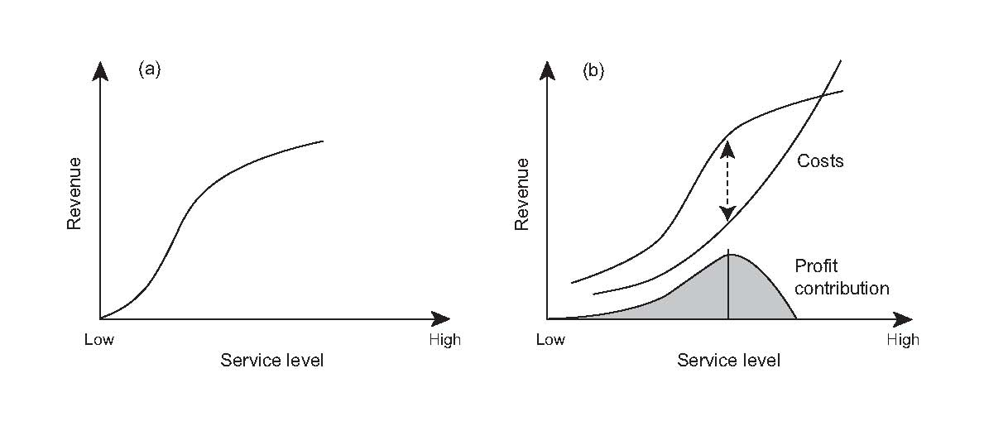

(a) Describe the dimensions for measuring the customer service from the supply chain perspectives (Word limit: 50) **2 Marks**

(b) Interpret the graph with a suitable example. (Word limit: 200) **3 Marks**

**Q.3** Briefly explain the conditions (or product categories) in which three model for supply chain (as presented in the diagram) would be suitab**l**e (Word limit: 200) **5 Marks**

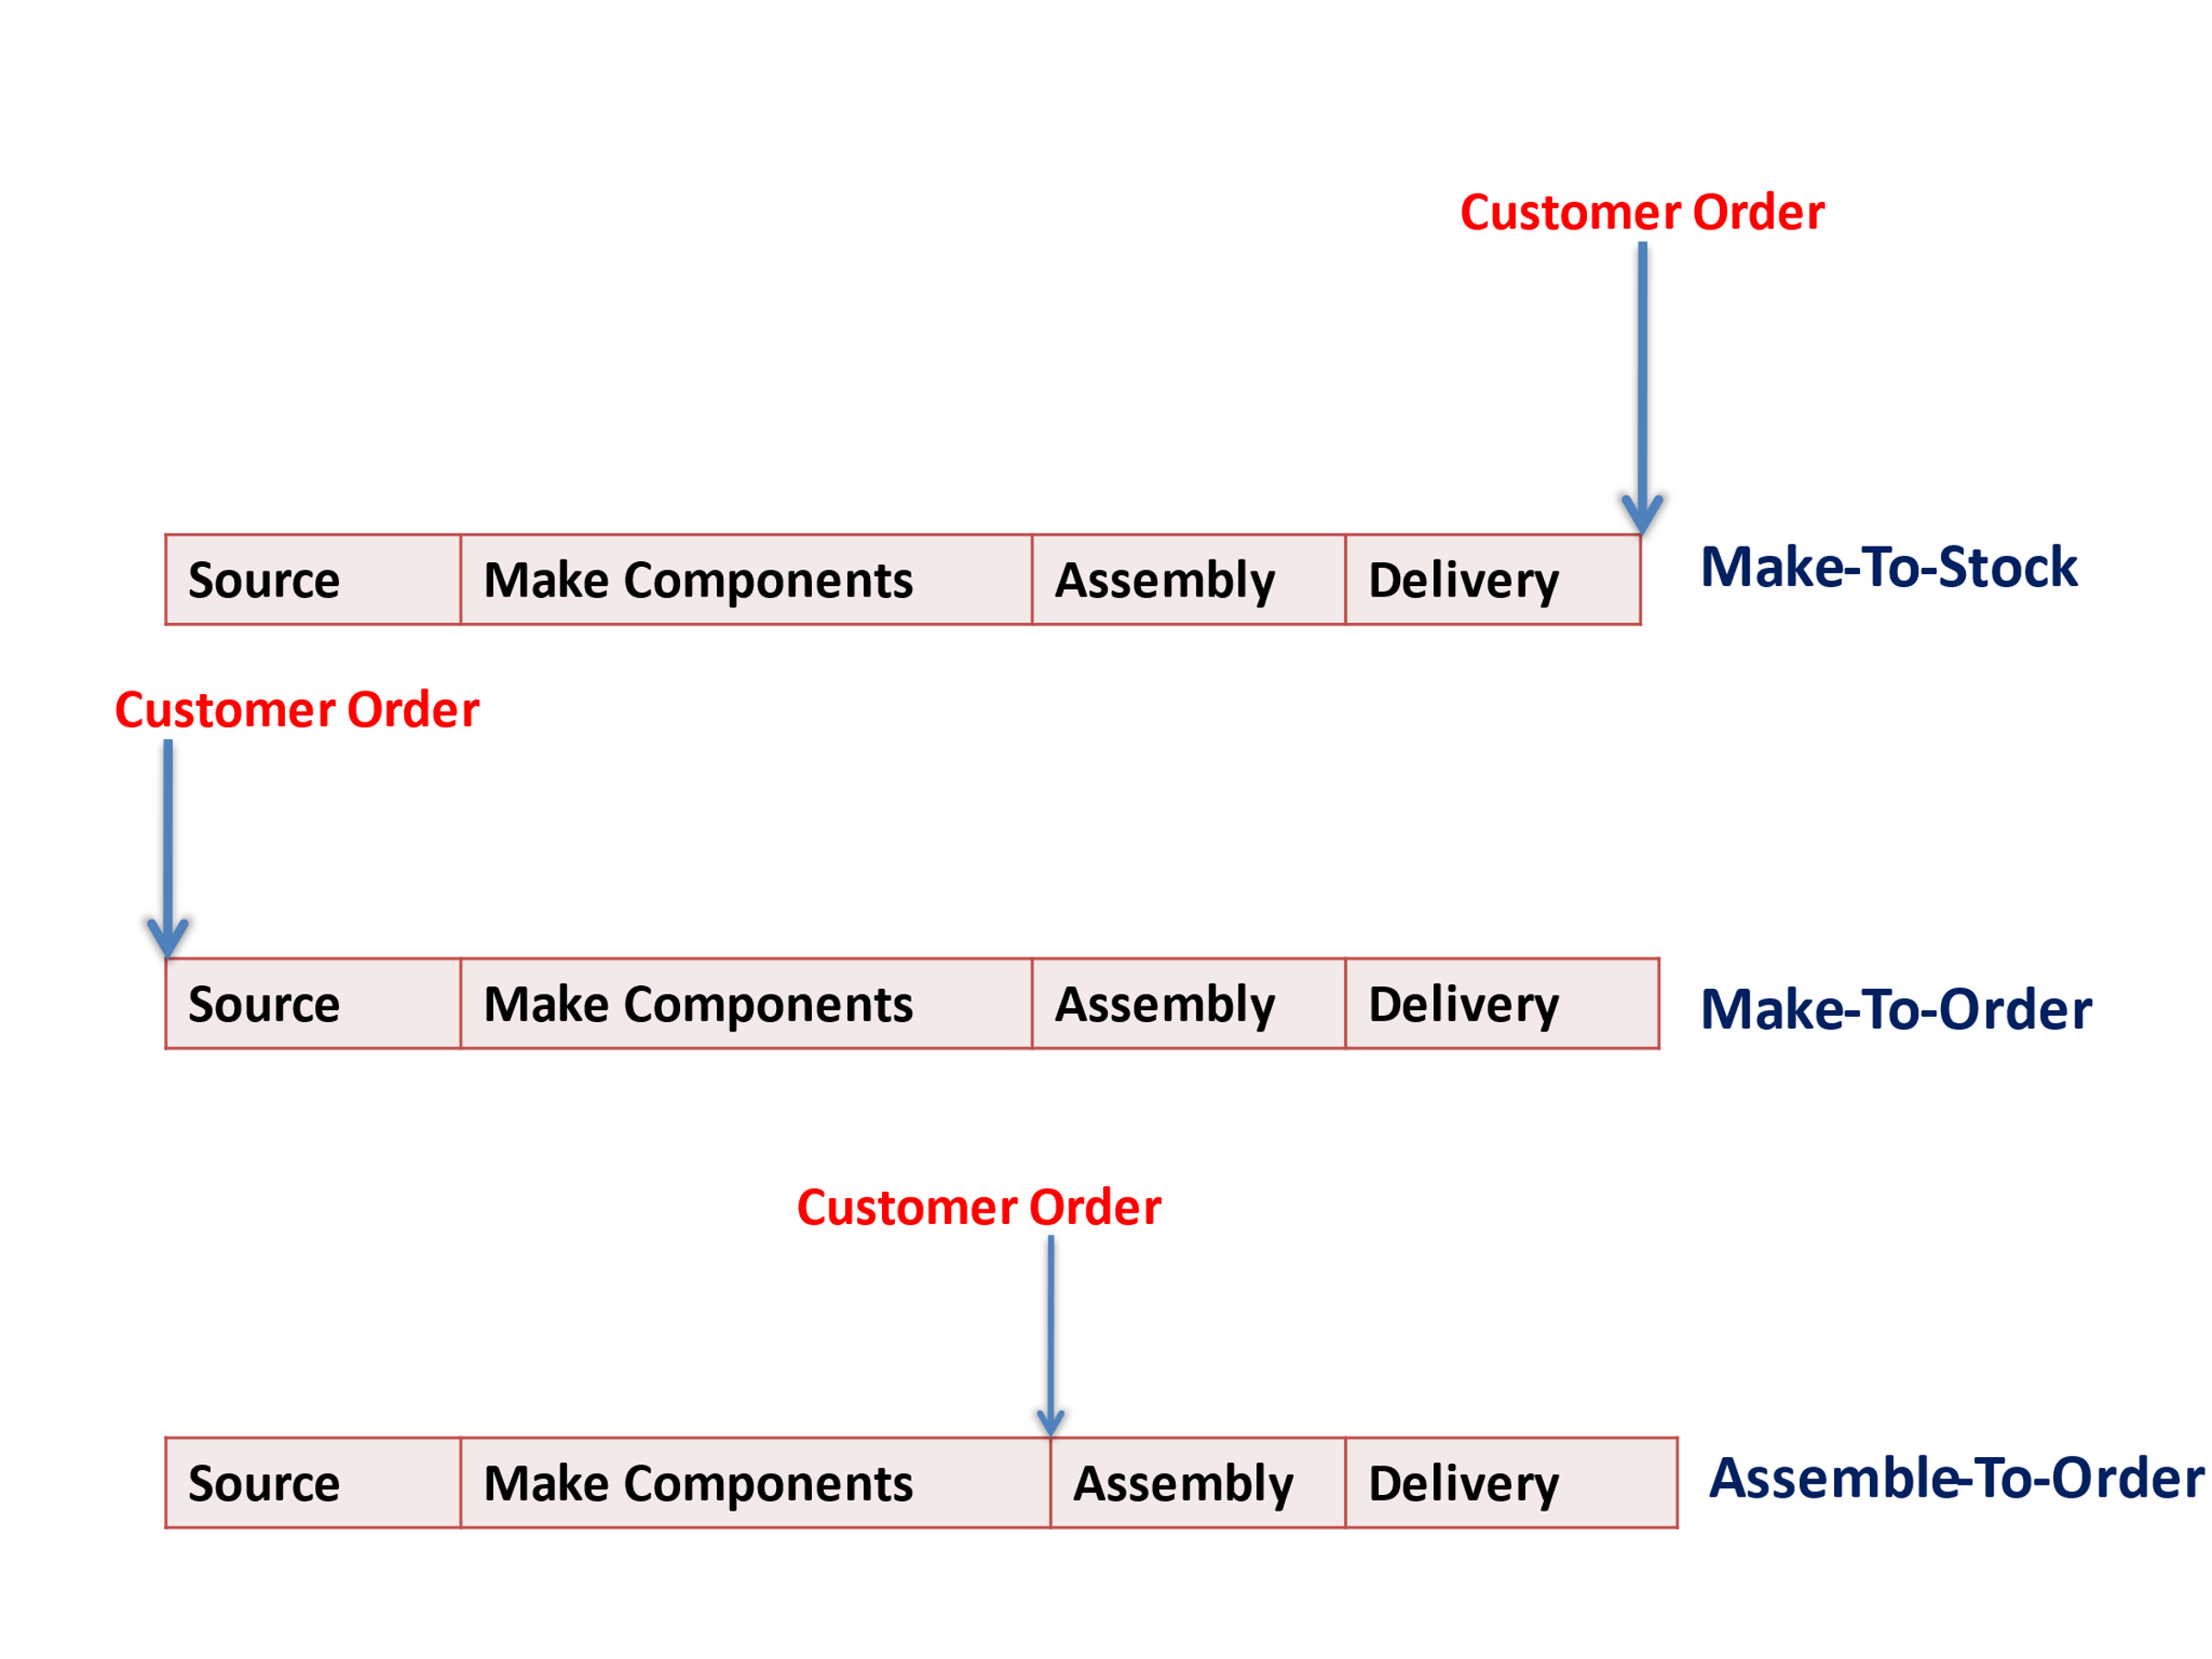

**Q.4** A bakery keeps stock of a particular brand of cake. Previous experience shows the daily demand pattern for the item with associated probabilities as given below

|  |  |
| --- | --- |
| **Daily Demand (Quantity)** | **Probability** |
| 0 | 0.01 |
| 10 | 0.2 |
| 20 | 0.15 |
| 30 | 0.50 |
| 40 | 0.12 |
| 50 | 0.02 |

Use the following sequence of random numbers to simulate the demand for next 10 days.

Random No: **25,39,65,76,12,05,73,89,19,49**. Also, estimate the daily average demand for the cakes on the basis of simulated data. **5 Marks**

**Q.5** The company trading in motor vehicle spare parts wishes to determine the levels of stock it should carry for the items in its range. The demand is not certain and there is a lead time for stock replenishment. For an item A, the following information is obtained

**Demand (units/day) Probability**

3 0.1

4 0.2

5 0.3

6 0.3

7 0.1

Carrying cost (per unit/day) : Rs.2

Ordering cost (per order) : Rs.50

Lead time for replenishment : 3 days

Stock in hand at the beginning : 20 units

Conduct a simulation run over a period of 10 days with the objective of the evaluating the inventory rule –Order 15 units when the present inventory plus any outstanding order falls below 15 units. **5 Marks**

**--------------------------------------------------------------------------------------------------------------------------**